ASSIGNMENT 1 – PYTHON FUNDAMENTALS

1.Write Python code that prints your name, student number and email address

print(“Seetha V”)

print(“32”)

print(“[seetha917@gmail.com](mailto:seetha917@gmail.com)”)

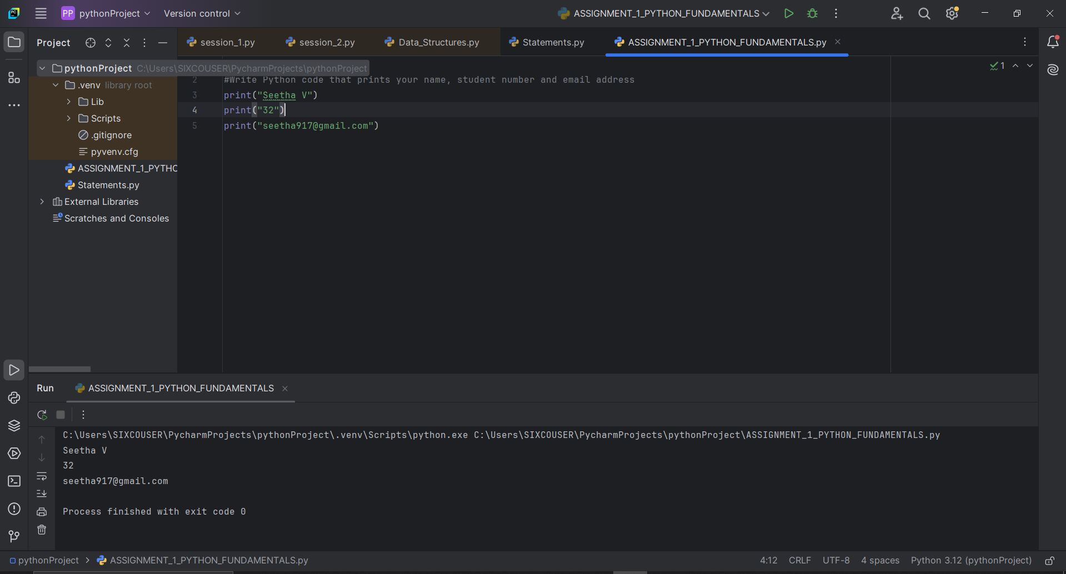

2.Write Python code that prints your name, student number and email address using escape sequences.

print(“Seetha V\n32\n[seetha917@gmail.com](mailto:seetha917@gmail.com)”)

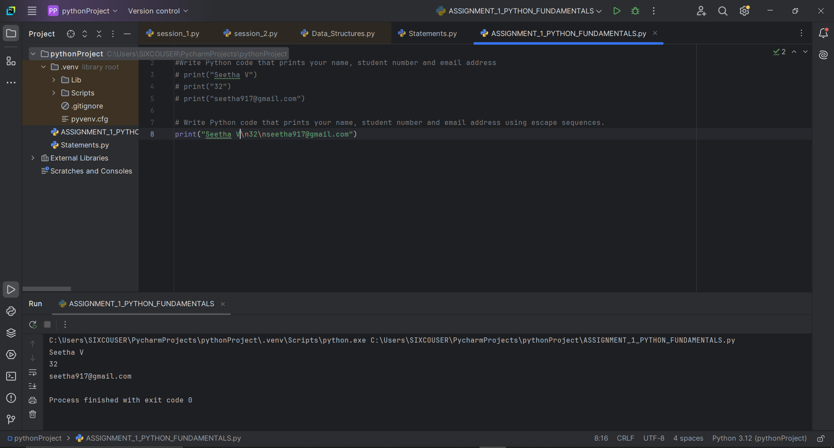

3.Write Python code that add, subtract, multiply and divide the two numbers. You can use the two numbers 14 and 7.

x=14

y=7

print( x , "+", y , "=", x+y )

print( x , "*", y ,"=", x*y )

print( x , "-" , y , "=" , x-y )

print( x , "/" , y , "=" , x//y )

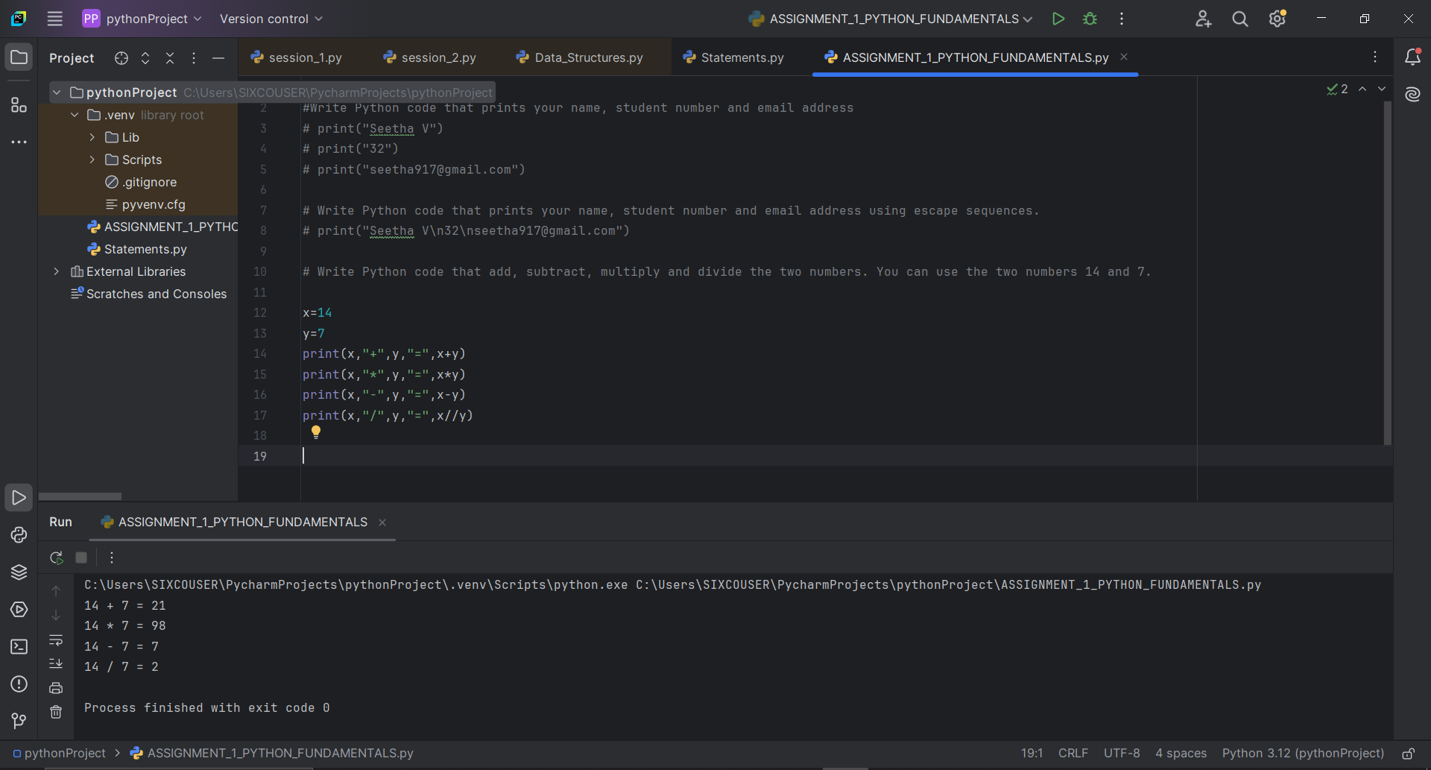

4.Write Python code that displays the numbers from 1 to 5 as steps.

for i in range(1,6):

print(i)

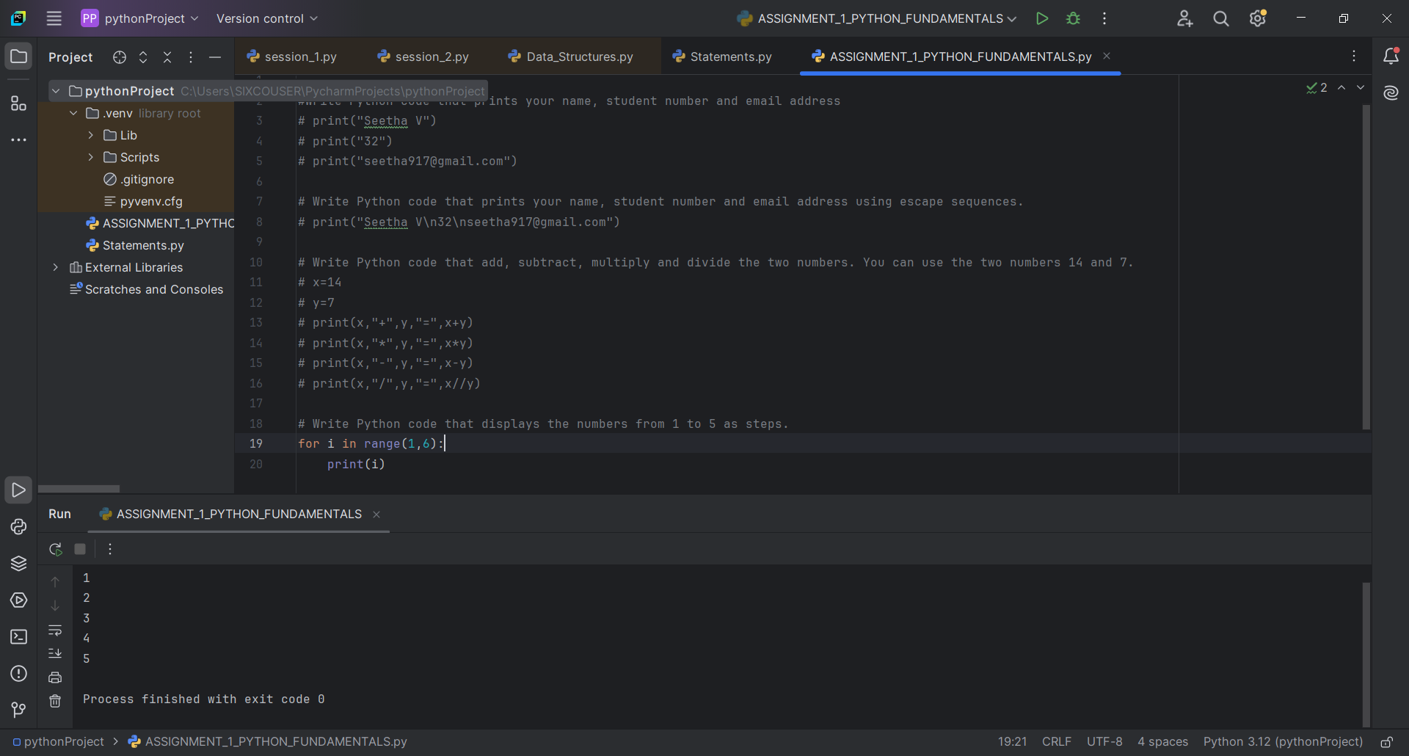

5.Write Python code that outputs the following sentence (including the quotation marks and line break) to the screen: An example runs of the program: "SDK" stands for "Software Development Kit", whereas "IDE" stands for "Integrated Development Environment".

print( ' \"SDK\" stands for \"Software Development Kit\", whereas\n\"IDE\" stands

for \"Integrated Development Environment\" ' )

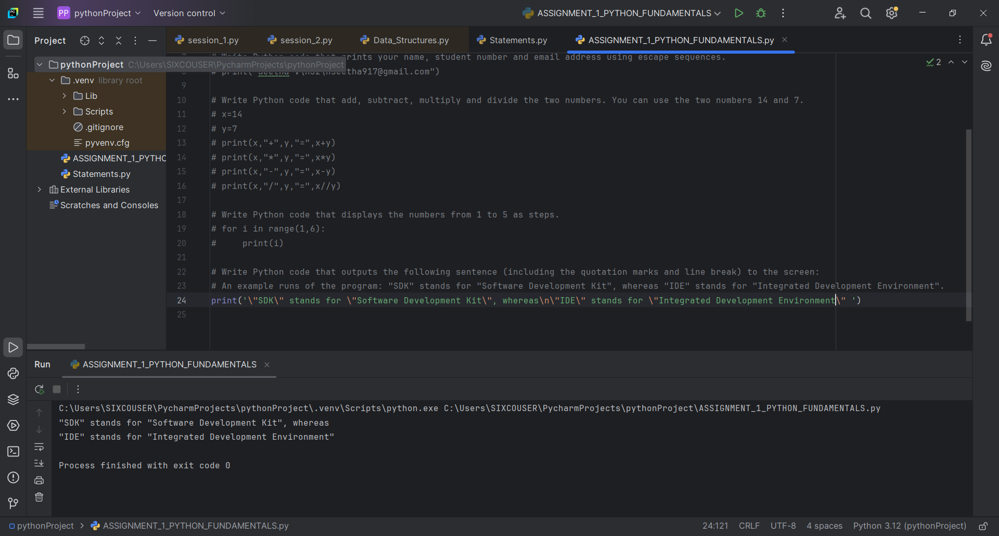

6. Practice and check the output print("python is an \"awesome\" language.") print("python\n\t2023") print('I\'m from Entri.\b') print("\65") print("\x65") print("Entri", "2023", sep="\n") print("Entri", "2023", sep="\b") print("Entri", "2023", sep="*", end="\b\b\b\b")

print("python is an \"awesome\" language.")

print("python\n\t2023")

print('I\'m from Entri.\b')

print("\65")

print("\x65")

print("Entri", "2023", sep="\n")

print("Entri", "2023", sep="\b")

print("Entri", "2023", sep="*", end="\b\b\b\b")

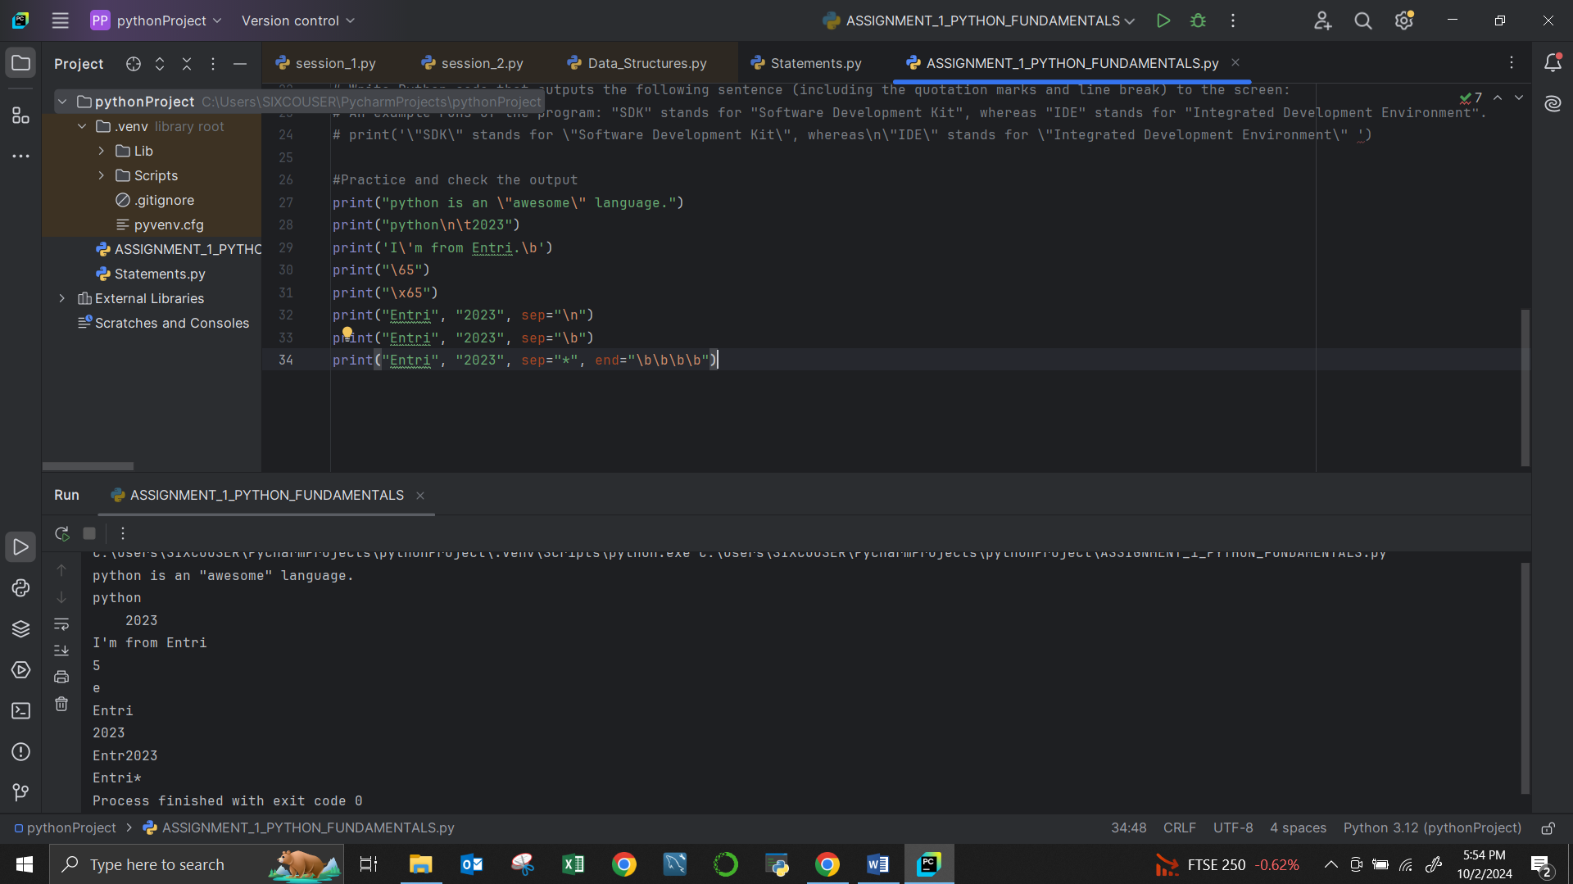

7. Define the variables below. Print the types of each variable. What is the sum of your variables? (Hint: use a type conversion function.) What datatype is the sum? num=23 textnum="57" decimal=98.3

num=23

textnum="57"

decimal=98.3

print("TYPE OF NUM IS", type(num))

print("TYPE OF TEXTSUM IS", type(textnum))

print("TYPE OF DECIMAL IS", type(decimal))

sum = num + int(textnum) + decimal

print("SUM=",sum)

print("TYPE OF SUM IS", type(sum))

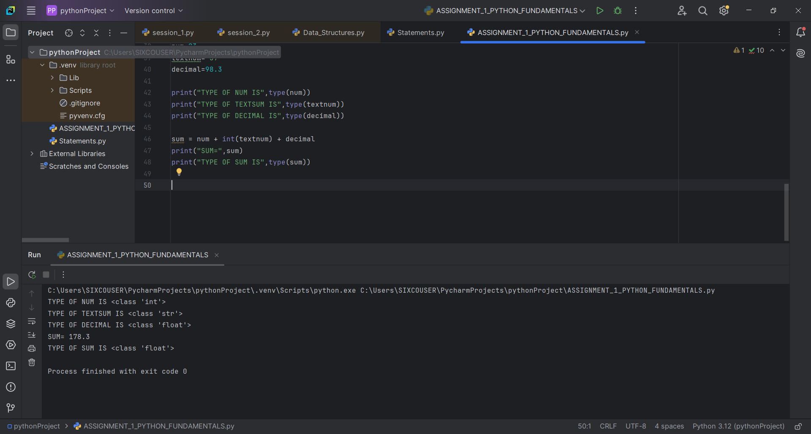

8.Calculate the number of minutes in a year using variables for each unit of time. print a statement that describes what your code does also. Create three variables to store no of days in a year, minute in a hour, hours in a day, then calculate the total minutes in a year and print the values (hint) total number of minutes in an year =No.of days in an year * Hours in a day * Minutes in an hour

no_of_days_in_year = 365

hours_in_a_day = 24

minutes_in_a_hour = 60

total_minutes_in_an_year = no_of_days_in_year * hours_in_a_day * minutes_in_a_hour

print("This code calculates the total number of minutes in a year.")

print("Total minutes in a year:", total_minutes_in_an_year,"minutes")

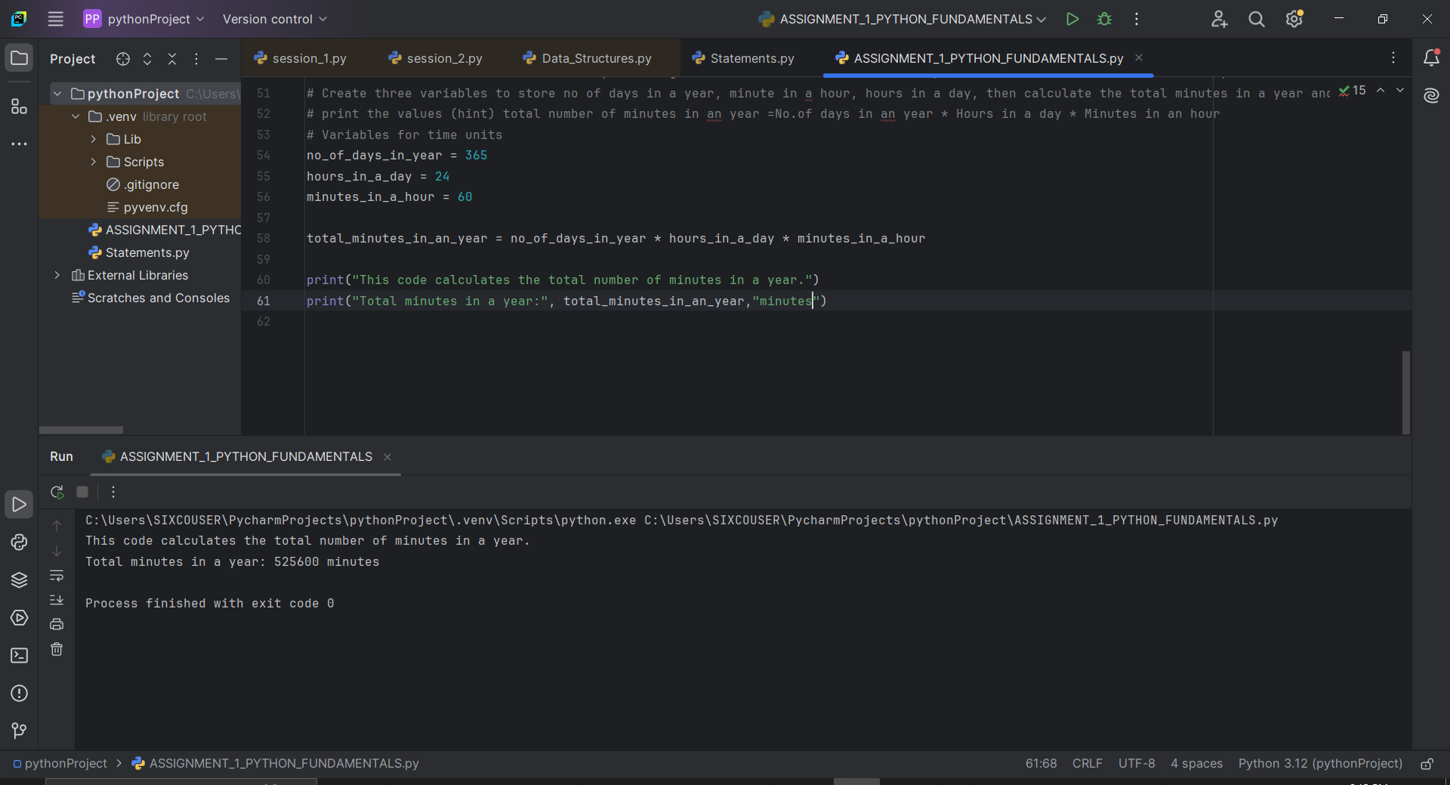

9. Write Python code that asks the user to enter his/her name and then output/prints his/her name with a greeting. An example runs of the program: Please enter you name: Tony Hi Tony, welcome to Python programming :)

user_name = input("Please enter your name: ")

print(f "Hi {user_name}, Welcome to Python programming :)")

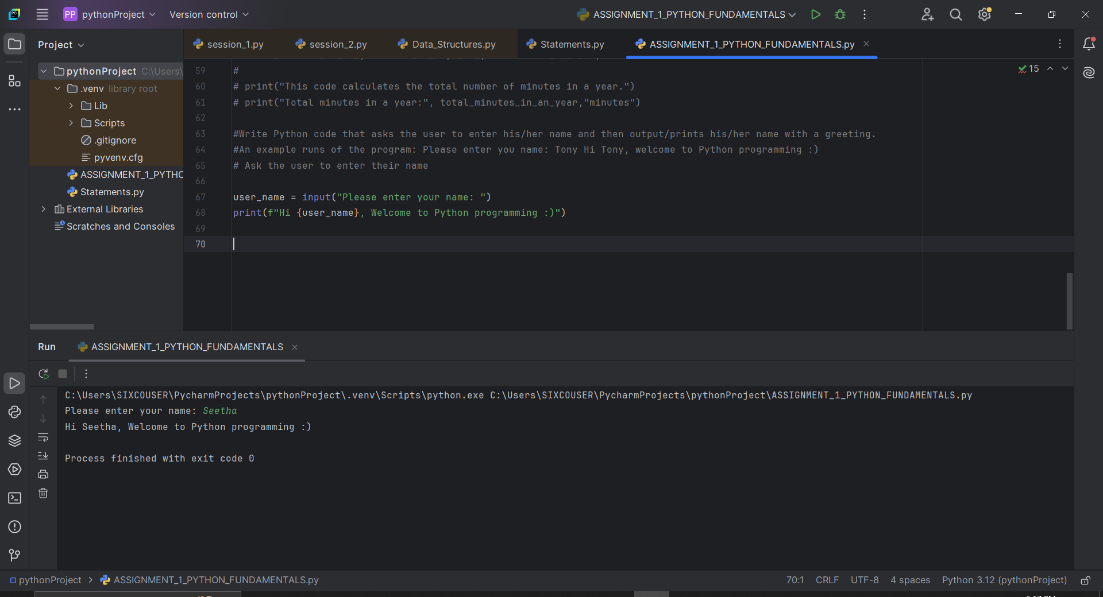

10. Name your file: PoundsToDollars.py Write a program that asks the user to enter an amount in pounds (£) and the program calculates and converts an amount in dollar ($) An example runs of the program: Please enter amount in pounds: XXX £ XXX are $ XXX

pounds = float(input("Please enter amount in pounds (£): "))

dollars = pounds * 1.33

print(f"£{pounds} = ${dollars}")

